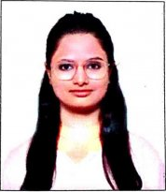

Faculty Profile

Ms. Gayatri Motiram Polakhare

|  |  |  |
| --- | --- | --- |
| **Qualifications** | **: B. Pharm** | |
| **Specialization** | **:Pharmacology** | |
| **Department** | **:Pharmacy** | |
| **Designation** | **:Lecturer** | |
| **Experience** | **Industry:00** | **Teaching:03 years** |
| **Publication** | **: Research 2, Review 2, Patent 1** | |
| **Award/Recognition** | **: NA** | |
| **Membership** | **: NA** | |
| **Email** | **:gayatripolakhare2830@gmail.com** | |